

Fake News

Detection

using NLP

PHASE IV

PROJECT SUBMISSION

Problem Statement:

Begin building the fake news detection model by loading and preprocessing the dataset. Load the fake news dataset and preprocess the textual data.

Data Cleaning:



Data cleaning is a process of removing inconsistencies in the dataset and incorrect values .It also in involves handling missing values either by removing them or assigning them average values. It helps to improve the efficiency of the model.

In the first step, we will only remove the unnecessary data points from the dataset which does not helps in improving the model performance.

Initially we import the necessary packages for our data cleaning process and also in the future purposes,

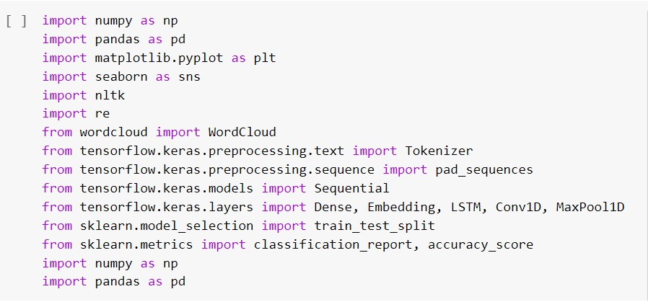

we use these packages in various stages of our cleaning process and also in the future in which we need to build models.

Here, we read the .csv files of true and fake news and then explore the count values of their subjects

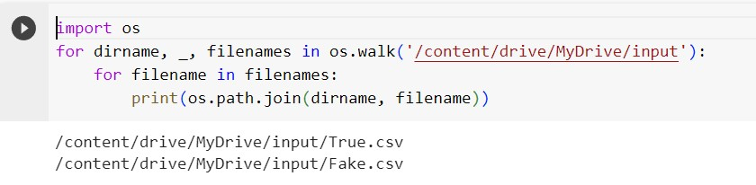

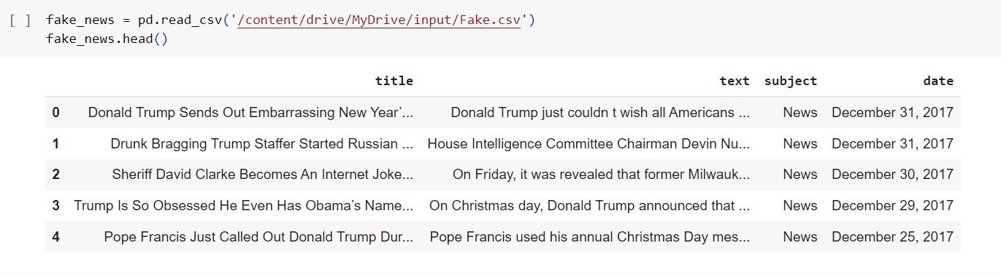

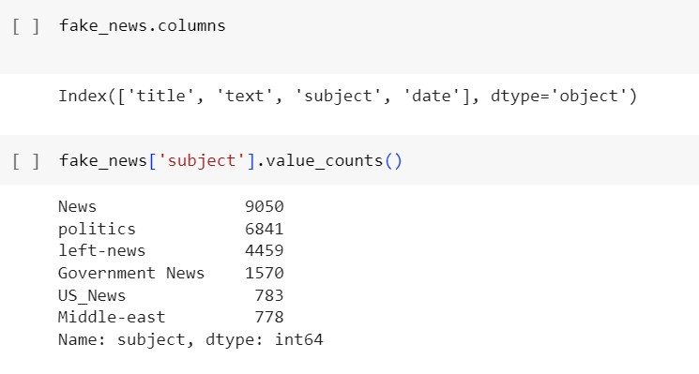

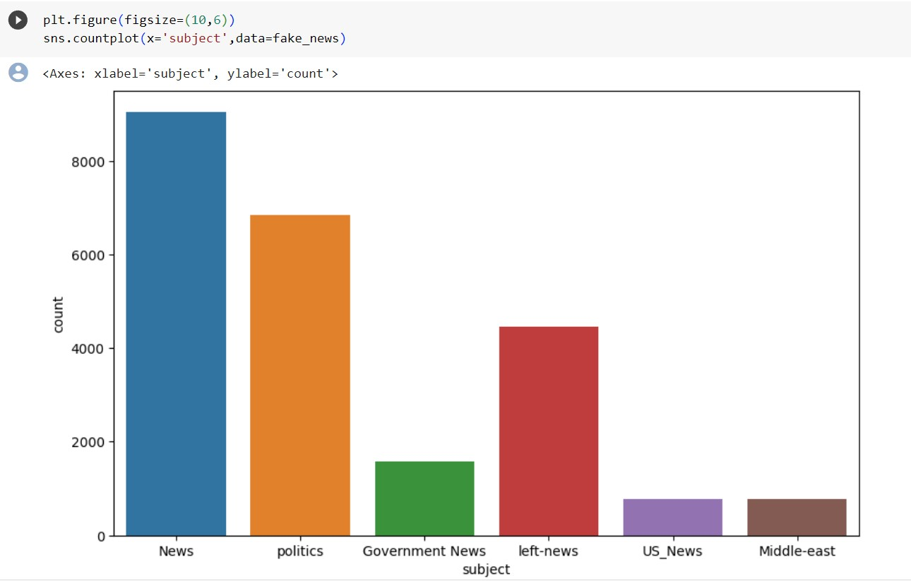

Here , we have used wordcloud to see that which word has mostly used for the fake news. By seeing that we can make a conclusion that which topic(about a person, event or anything) is mostly contains fake news).We also do the same for true news.

Word Cloud for Fake News:

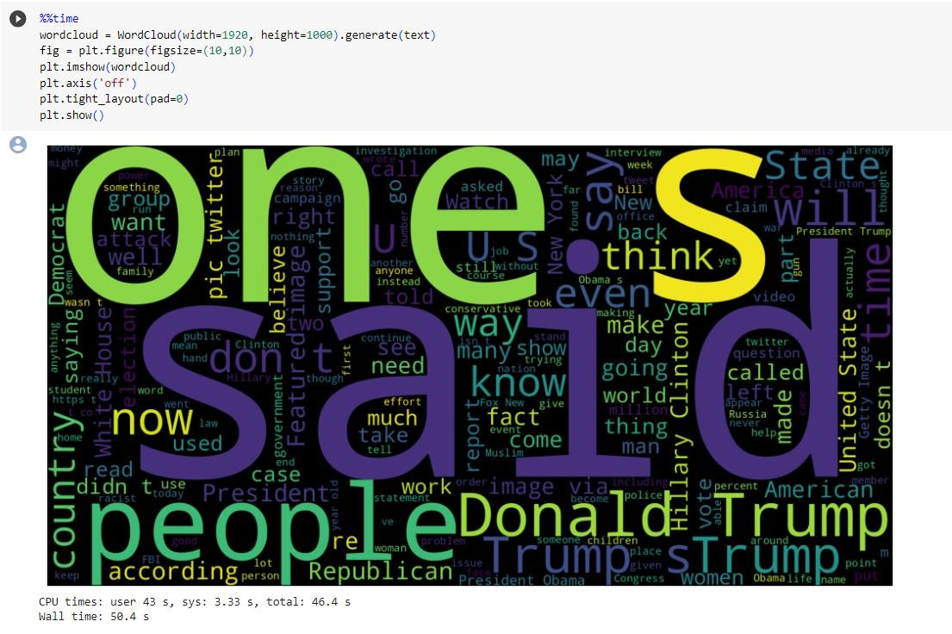

Word cloud for True News:

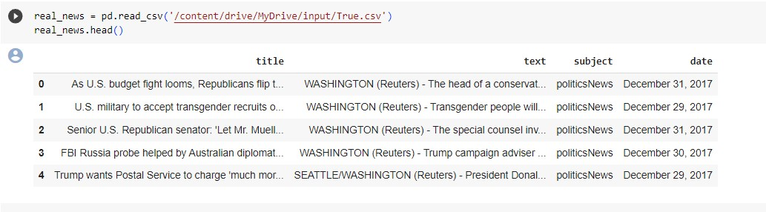

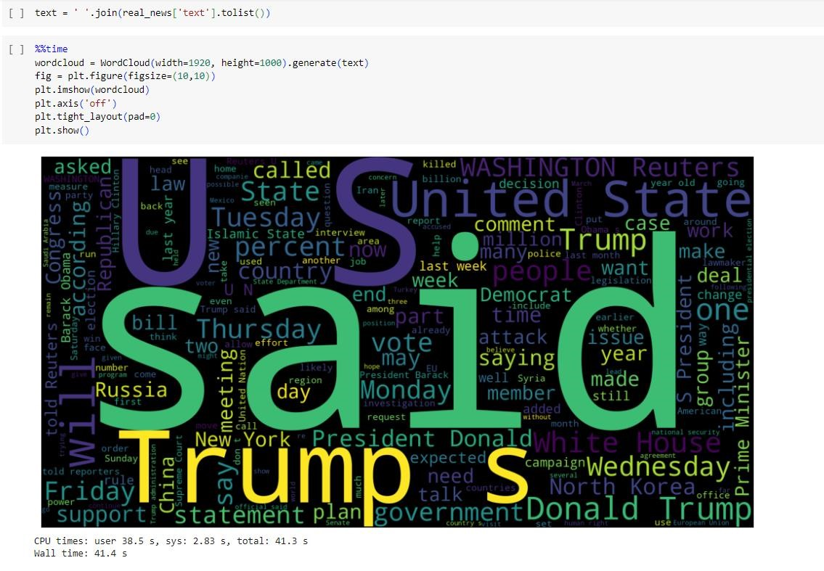

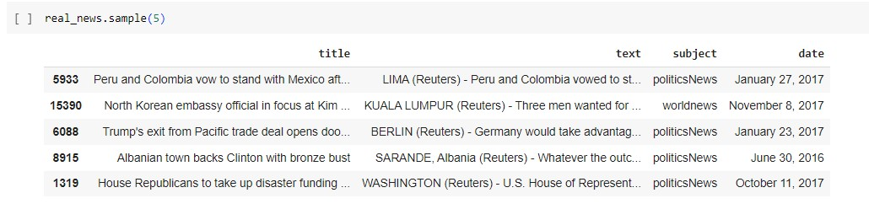

Let’s create a list of news lists in real_news.csv with unknown publishers by using the following code snippets

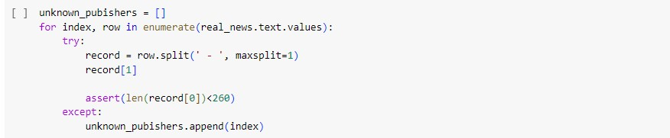

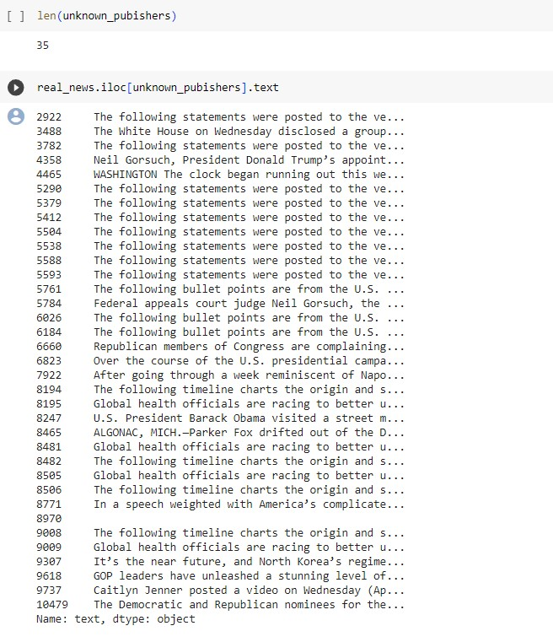

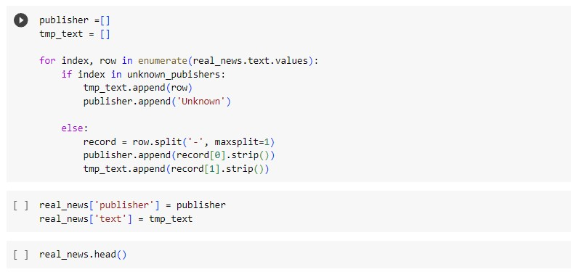

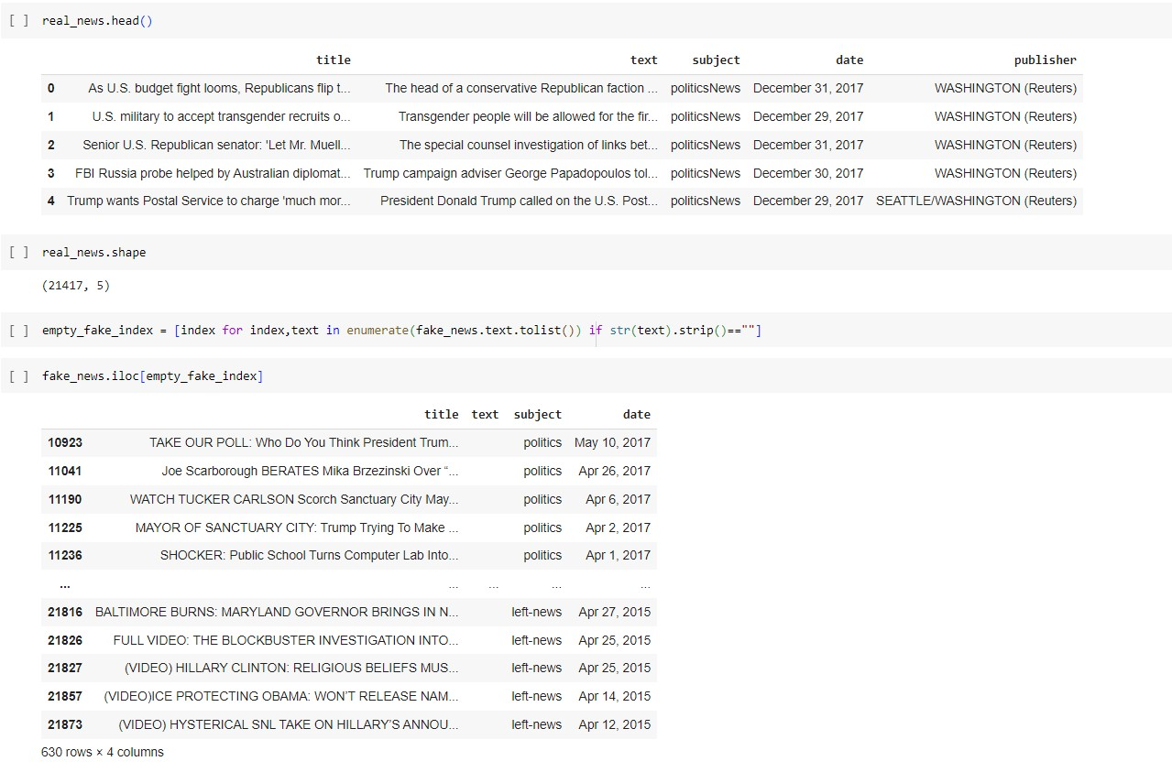

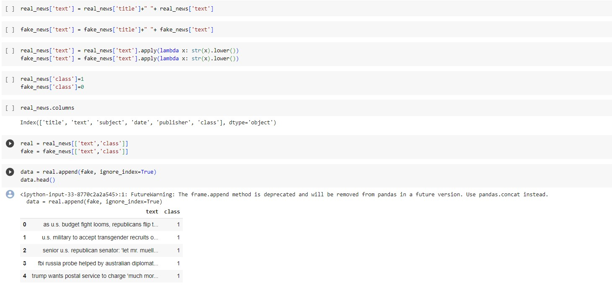

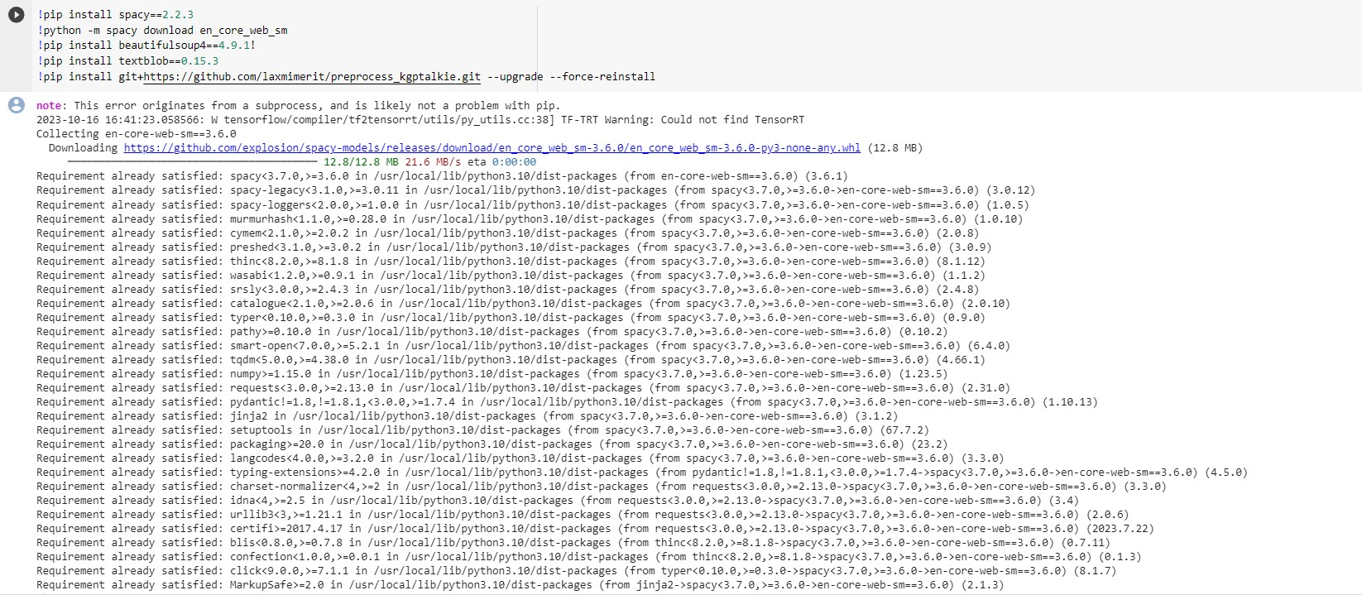



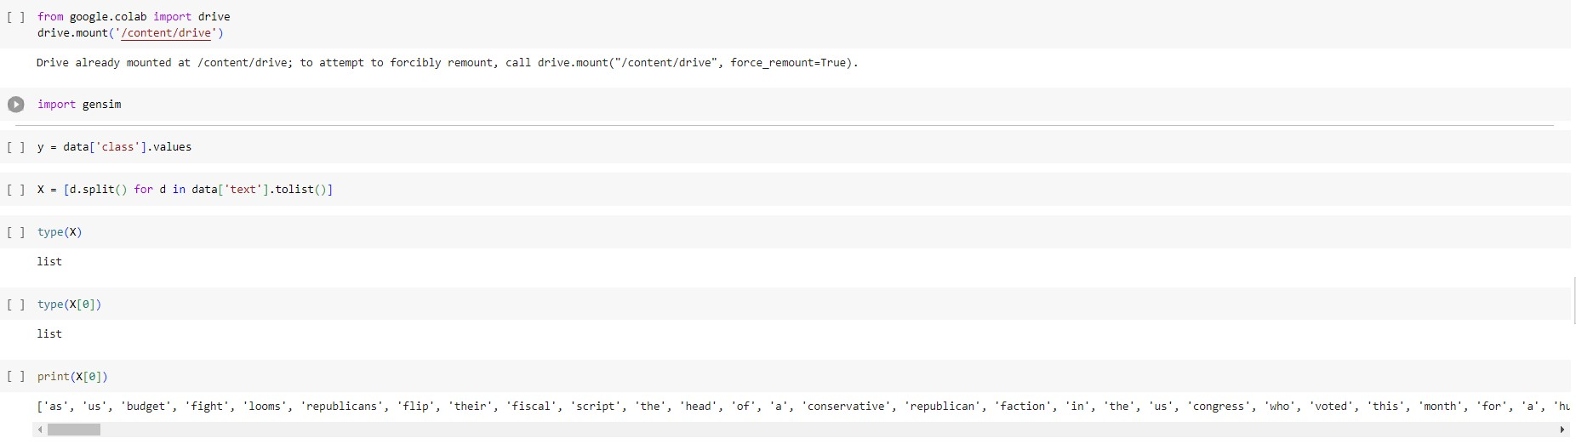

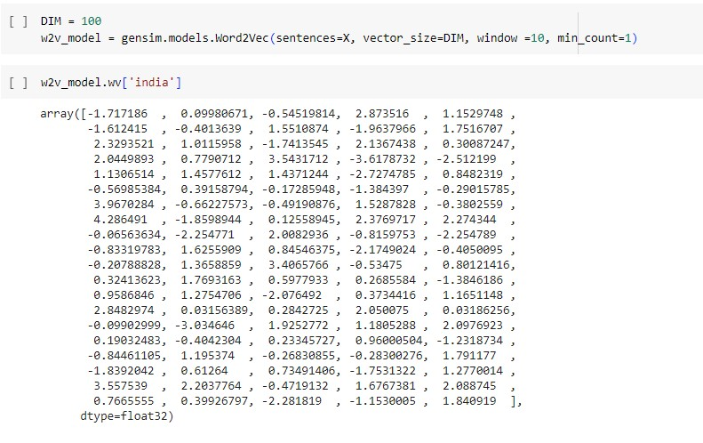

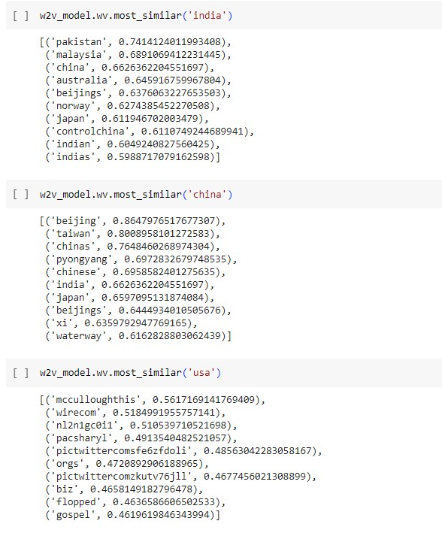

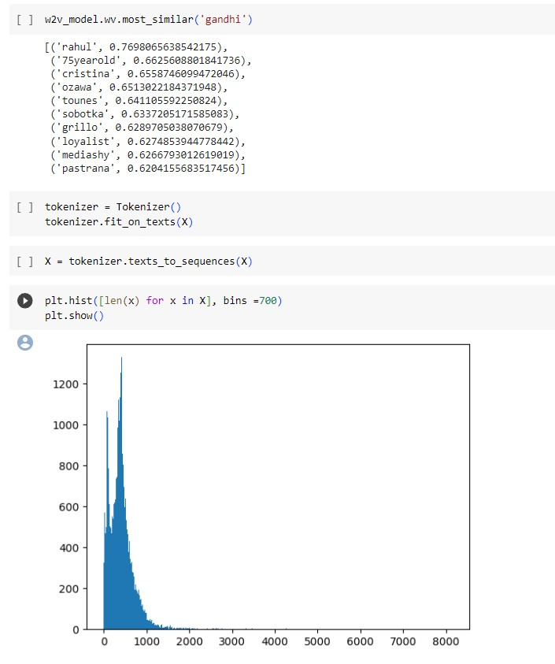

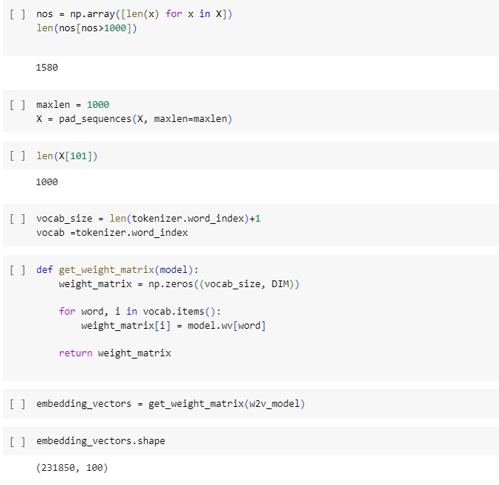

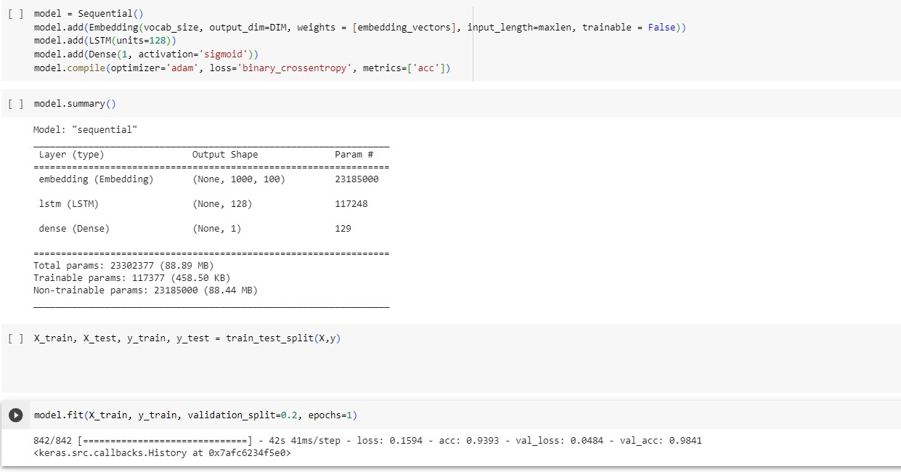

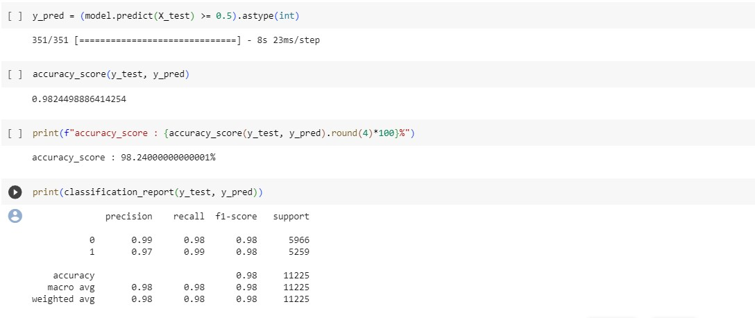

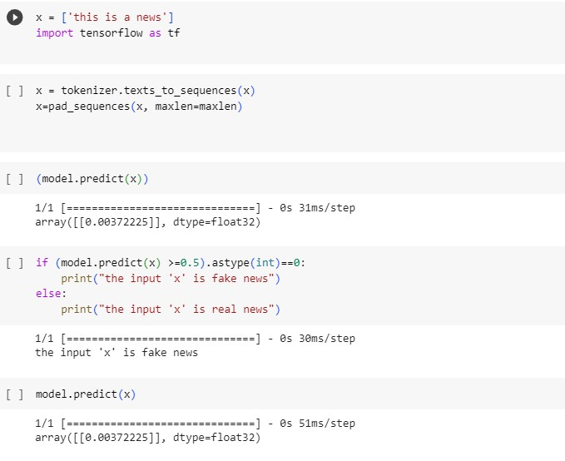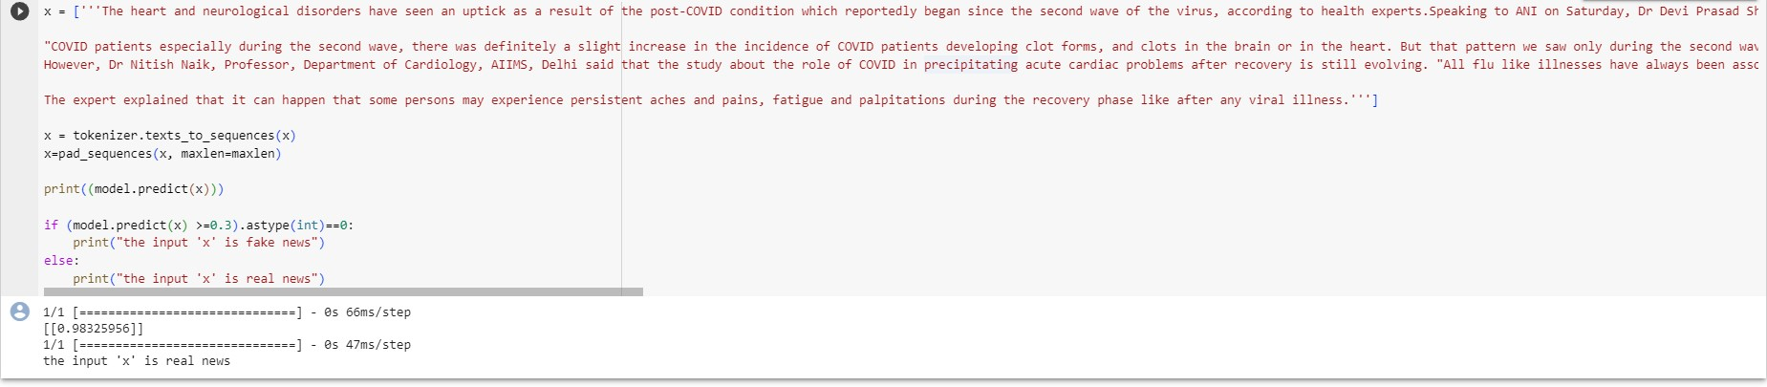

Conclusion:

In conclusion, utilizing Natural Language Processing (NLP) techniques for fake news detection has proven to be a significant advancement in combating misinformation. The model developed demonstrates the potential of machine learning in identifying deceptive content, contributing to the ongoing efforts to maintain the integrity of information online. By leveraging NLP algorithms, the accuracy and efficiency of fake news detection have been greatly enhanced, empowering users to make informed decisions and fostering a more reliable digital information ecosystem. As we move forward, continued research and development in this field will play a pivotal role in ensuring the authenticity and trustworthiness of online content, thereby promoting a healthier and moreinformed society.

